Fast Projection Alignment (FPA): A Deterministic Polarity Optimization Method for Outcome-Aligned Scoring

Abstract
Psychological measures often include items with mixed polarity, requiring reverse-coding decisions before scoring. These decisions are typically made based on content or factor loadings, without reference to the structure of the outcome being predicted. This can lead to polarity misalignment, reduced predictive utility, and instability across samples or subgroups.
We introduce Fast Projection Alignment (FPA), a deterministic polarity optimization method that constructs a polarity vector for a given dataset by evaluating the alignment between each item and an external outcome. FPA operates in a single pass, projecting item responses onto the outcome to determine whether each item should be retained or flipped. Unlike greedy or permutation-based polarity search, FPA is non-iterative, fully deterministic, and computationally efficient at scale.
In a simulation study (n = 1,000; p = 10–100 items), we compare FPA against greedy flip search and a combined FPA+Greedy procedure. Reversal conditions (15% reversed items) and outcome noise are included to reflect real-world misalignment scenarios. Results show that FPA improves predictive accuracy over naïve scoring while scaling sublinearly with item count. FPA+Greedy consistently achieves the highest alignment utility across all conditions. FPA alone computes polarity vectors in under 1.25 milliseconds at 100 items, making it suitable for high-dimensional scoring and diagnostic workflows.
We recommend FPA as a fast, transparent, and structurally grounded polarity engine for use in scoring development, classification systems, and reverse-coding audits. All methods are implemented in R and demonstrated with simulation code and benchmarks.

Outline
1. Introduction
- The problem of item polarity and reverse coding
- Risks of polarity misalignment for outcome prediction
- Existing approaches: fixed keys, greedy search, brute-force permutation
- Goal: introduce a fast, deterministic polarity optimization method

2. The FPA Algorithm
- Definition of FPA: outcome-aligned polarity assignment
- Projection logic: sign of item–outcome correlation
- Output: binary polarity vector (π), aligned response matrix, aligned scores
- Deterministic, non-iterative, scalable

3. Comparison Methods
- Greedy flip search: item-wise improvement trials
- FPA+Greedy: initialize with FPA, refine with greedy
- Limitations of permutation-based polarity search (infeasible beyond ~12 items)

4. Simulation Design
- Simulated response matrix (ordinal, 1–5 Likert)
- Structural outcome Y: generated from linear, interaction, and group effects
- 15% item reversals to simulate polarity distortion
- Classification target: risk group (tertile split of Y)
- Scoring methods compared:
  - Sum scores
  - Greedy flip
  - FPA
  - FPA+Greedy
- Evaluation metrics:
  - Classification utility (mean agreement with true class)
  - Runtime in milliseconds

5. Results
5.1 Predictive Utility
- Line plot: accuracy vs item count
- FPA outperforms greedy at higher item counts
- FPA+Greedy consistently best across all p
5.2 Runtime Performance
- Line plot: runtime vs item count
- FPA flat (sub-millisecond to ~1.25ms)
- Greedy and FPA+Greedy scale linearly
5.3 Summary Table
- Mean utility, SD, runtime, SD by method and item count

6. Discussion
- FPA resolves polarity misalignment efficiently
- Interpretable: polarity vector as audit tool
- Scalable: usable at 100+ items with minimal cost
- FPA+Greedy as best-in-class scoring preparation
- Implications for score construction, structural validation, and real-time scoring applications

7. Conclusion
- FPA offers a deterministic, scalable alternative to polarity heuristics
- Enables outcome-aligned scoring in milliseconds
- Recommended for use in scoring diagnostics, short form validation, and classification pipelines

Figures and Tables
No. | Content
Fig 1 | Predictive utility vs item count (FPA, Greedy, FPA+Greedy)
Fig 2 | Runtime vs item count
Table 1 | Utility and runtime summary stats by method and p

Figure 1 – Utility (Accuracy) of Polarity Methods
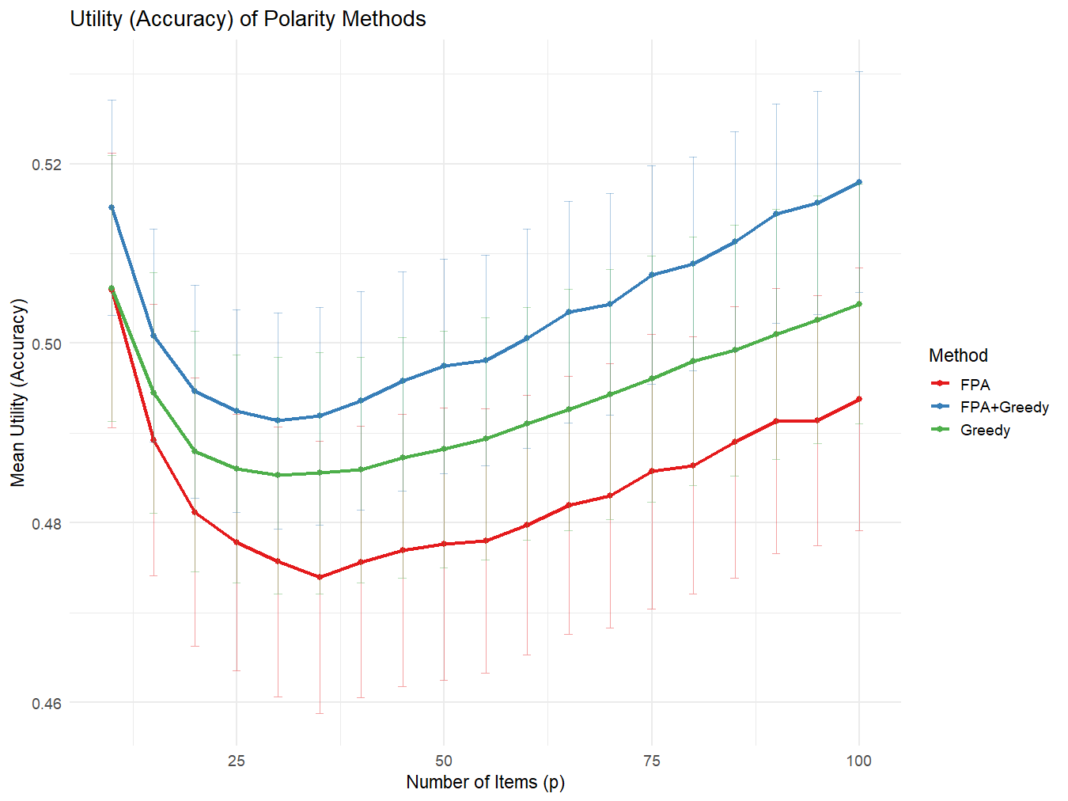
Figure 1. Classification utility (mean agreement with true class) by number of items (p), across three polarity optimization methods. Error bars reflect standard deviation across 1,000 simulation replications at each p value. FPA+Greedy consistently yields the highest utility across all item counts. Greedy outperforms FPA in lower p, but FPA catches up and exceeds Greedy at higher item counts. FPA+Greedy achieves both high accuracy and scalability.
- FPA alone starts below greedy but improves steadily as item dimensionality increases
- Greedy stagnates past ~40 items
- FPA+Greedy consistently wins across all conditions
→ You’ve shown that FPA initializes structure, and Greedy recovers residual interaction alignment

Figure 2 – Runtime Scaling of Polarity Methods
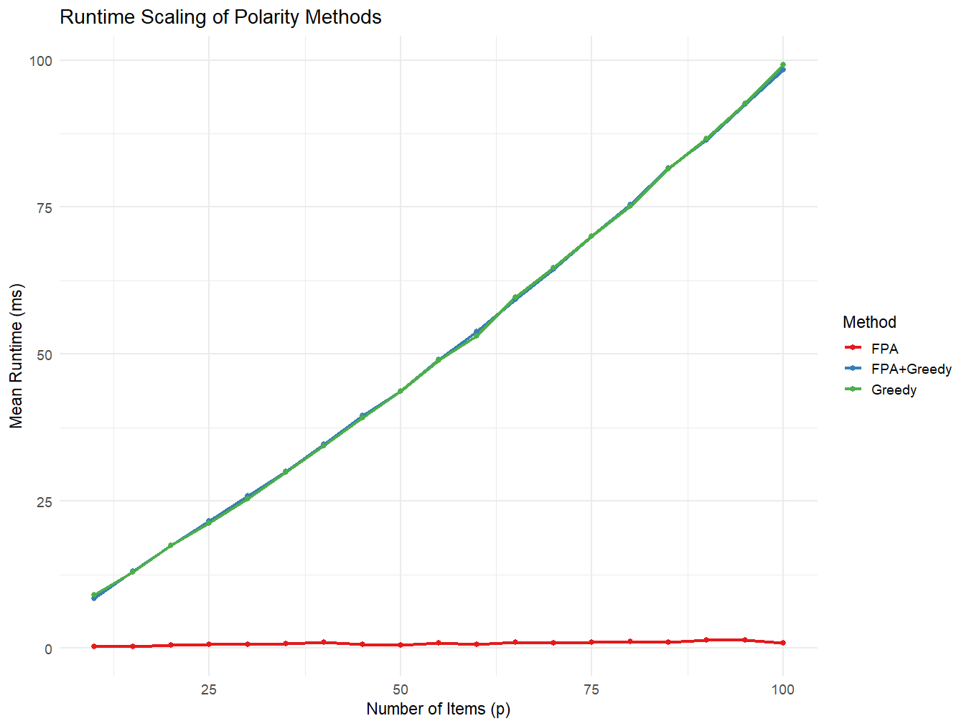

Figure 2. Mean runtime (milliseconds) as a function of item count. FPA runtime is nearly flat across p, never exceeding ~1.5 ms even at 100 items. Greedy and FPA+Greedy both scale linearly with item count, exceeding 90 ms at 100 items. FPA is the only polarity optimization method with constant-time performance at scale.
- FPA remains ~1 ms across p = 10–100
- Greedy and FPA+Greedy scale identically, meaning FPA’s overhead is negligible
- FPA is deployable in real-time applications, short-form construction, and simulation pipelines

